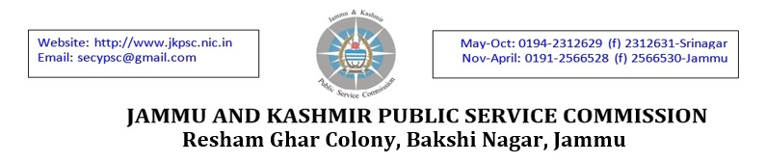
Subject: Interview schedule for the post of Assistant Professor (Botany) in Higher Education Department.

NOTICE
DATED: 14.01.2017
---

In continuation to Commission’s notice dated 10.01.2017, it is hereby notified thatSh. Tariq Ahmad Dar S/o Sh. Mohd. Maqbool Dar R/O UttersooNajiGund, Anantnag, Kashmir is also called for interview for the post of Assistant Professor (Botany) under RBA Category on 20.01.2017 at 10.00 A.M. in the office Complex of J&K Public Service Commission, ReshamGhar Colony, Bakshi Nagar, Jammu.

Further, in pursuance of Hon’ble Court orders in SWP No.1467/2016 titled Dr. Saba Mughal Vs State & Others the petitioner namely Dr. Saba Mughal is also called for interview for the post of Assistant Professor (Botany) on 20.01.2017 at 10.00 A.M. in the office Complex of J&K Public Service Commission, ReshamGhar Colony, Bakshi Nagar, Jammu and the permission to appear in the interview is purely provisional at her own risk and responsibility and subject to final outcome of the writ petition.

The other terms and conditions as notified vide notice dated 10.01.207 shall remain same.

Sd/-
Deputy Secretary,
J&K Public Service Commission.

No: PSC/DR/Asstt.Prof/16 Dated: 14.01.2017
Copy to the:-
1. Secretary to Government, Higher Education Department, Civil Secretariat, Jammu.
2. Director, Information, J&K Government, Jammu for favour of getting the notice published in atleast two local leading English dailies of Jammu/Srinagar.
3. Director Doordarshan, Jammu/ Srinagar/ Leh/ Kargil/ Bhaderwah/ Rajouri with the request to broadcast/telecast the schedule in the news bulletin/RozgarSamachar and make special announcement atleast for three consecutive days.
4. General Manager, Government Press, Srinagar for publication of the notice in the next issue of the Government Gazette.
5. Deputy Secretary/Under Secretary, J&K Public Service Commission.
6. Private Secretary to Chairman, for information of the Hon’ble Chairman.
7. Private Secretary to Member_____________________ for information of the Hon’ble Member.
8. I/C website for uploading the notice on website.
9. I/C Camp office, Srinagar for pasting the notice on the notice board.
10. Main file/programme file.

